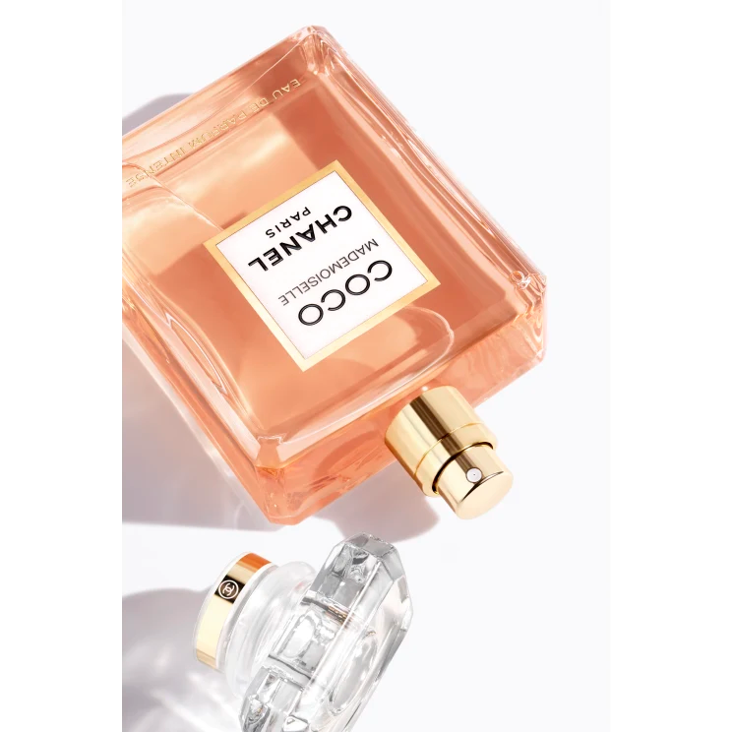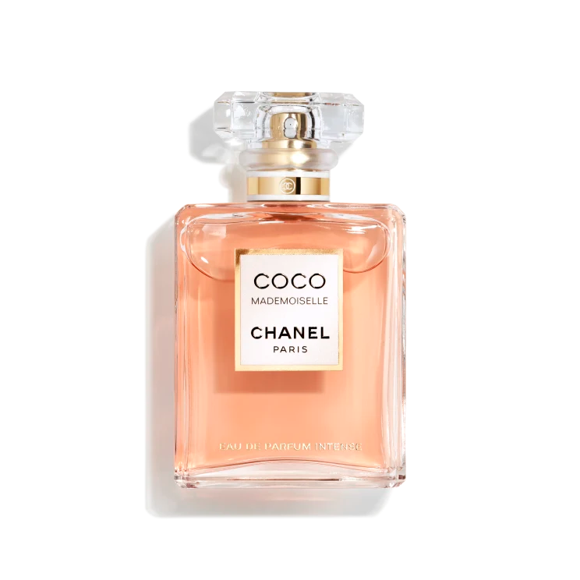

**COCO MADEMOISELLE**

**$175**

Tax Included.

Spray 100 mL

IN STOCK

**Product Details**

An intense facet of the COCO MADEMOISELLE personality emerges to forge a powerful, deep ambery fragrance that is irresistible in every way.

A double name, a double personality. Independent and endearing, mischievous and provocative, light and exuberant—revealing a playful and rebellious woman free to reinvent herself day after day.